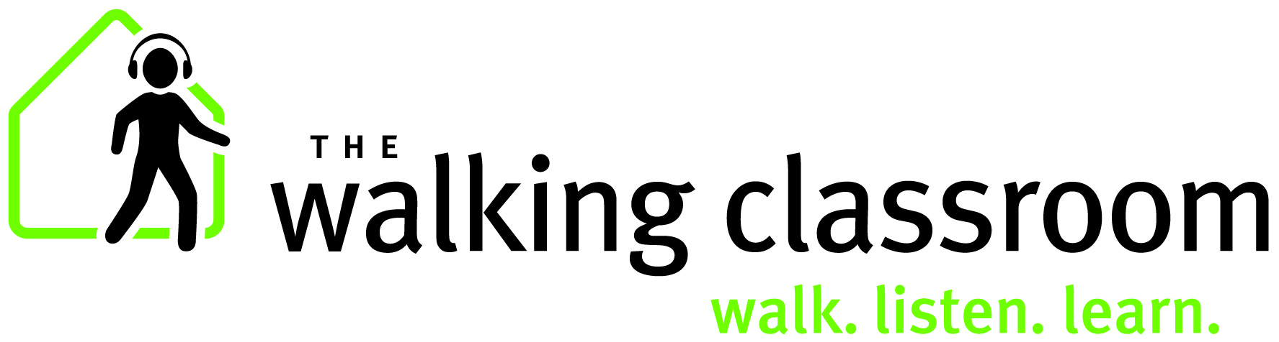

The Walking Classroom (TWC) is an award-winning nonprofit program offering high-quality academic enrichment paired with structured physical activity for traditional classrooms and out of school time learning (afterschool, before school, extended school breaks and summer programs). Students strengthen their physical, mental, and academic health as they listen to custom-written, kid-friendly educational podcasts while they walk. They walk, listen, and learn!

Academic Enrichment:
- All podcasts are about 15 minutes long and align with core curriculum.
  - Topics include Language Arts, Social Studies, and Science
- Walking, listening, and learning differentiates instruction to meet the needs of diverse learning styles (particularly the needs of kinesthetic and auditory learners).
- Lesson plans for each podcast include discussion questions and comprehension quizzes.
- Kid-friendly educational content presented in engaging manner decreases summer learning loss.

Social Emotional Education –Character Values:
- Lesson plans contain thought-provoking discussion questions that relate podcast content back to student experience. Questions focus on honesty, integrity, perseverance, kindness, respect, responsibility, etc.

Physical Activity:
- Students gain 20 - 30 minutes of sustained physical activity each time the program is used.
- Walking is a non-competitive activity that is approachable & all can be successful.
- Research shows that exercise helps improve attention and concentration.

Health literacy & healthy habits:
- Each podcast begins with a brief, kid-friendly health literacy message.
- Students look forward to getting up and out for a walk. Healthy lifestyle habits are formed as students regularly experience the positive benefits of physical activity.

Sustainable:
- Not a one-time intervention. Audio players (“WalkKits”) come pre-loaded with over 100 podcasts – enough for an entire school year.
- Program is intended to be used year-round and may be used everyday.
- WalkKits have a one-year warranty and a life expectancy of 3 years.
- Equipment can be shared among teachers and reused year after year.

Staff needs:
- Online training provided free of charge for all adopters. Onsite training available.
- TWC provides free supplementary resources to complement program offerings.
- TWC offers free online professional development.
- Program is ready to go out of the box and requires no knowledge of technology or curriculum content. No updating is needed.

Family and Community Engagement:
- Visitors and volunteers are always welcome to join the educational walks.
- TWC offers a “home kit” that allows students to check-out the program and bring it home to share with family members.

